Stackability Matrix:

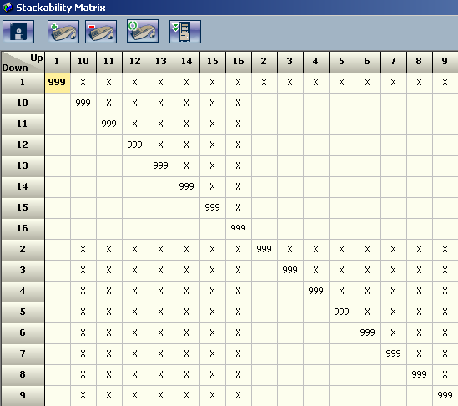

Is used to determine what can be stacked on top of what. This is currently based off of part family group. Each part family group will require an identical entry in the stackability matrix and it will have to be manually filled in to ensure that things that can be placed on top of others are setup correctly. This will require part families and part family groups to be organized by weight or “crushability”.

Crushability is the idea that if I place a heavy object on top of a light object with flimsy packaging, it is likely that the heavy object will crush the light object during shipping. Usually based on weight but can include considerations for carton density per pallet, packaging material, and anything else the customer deems relevant.

